COMP 3617

Assignment 1

Due Date:

2/19/2016 (@ 11:59PM)

Assignment Details

* The assignment is to create a very simple **Quiz App**
* If there are any technical details missing, try to make realistic assumptions and build on them – assume that you are contract developer who has been given these high level requirements to build this app
* Assignments must be done individually and there should be no sharing of work amongst students. If you are found in violation of this, you will receive a “0” for the assignment and will be reported to BCIT
* When you create the Android Application in Android Studio follow the exact instructions shown below with regard to naming the Application and Package. **This is required to enable me to identify whose submission is being graded and also to keep the number of assignment apps installed on my emulator to a small number.**

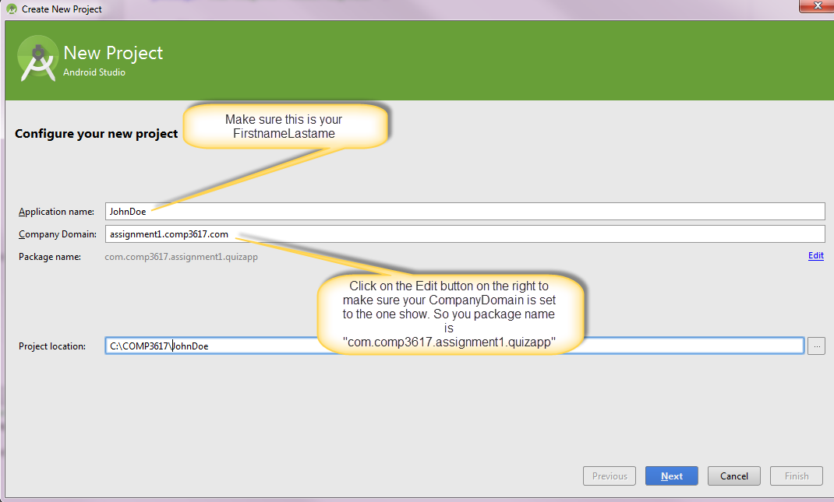

# To Hand In:

* Assignments must be zipped (.zip extension) up and uploaded to the drop box folder for the Assignment 1. **Do not use any other compression utility other than plain windows zip**
* Provide any relevant instructions, if you happen to have any for your app, when you upload your assignment
* Assignment Zip files should be named as follows: **FirstName LastName.zip** (Just zip up the Android Studio project for your app and this should follow the naming convention if you have followed the instructions)
* When you upload the zip file to drop box, add a comment stating how many hours you spent working on this assignment

# Requirements:

* The application allows the user to navigate through multiple questions (minimum of 5 ) and answer them by choosing the correct alternative displayed in the radio button group
* App comprises of two activities where the first one (MainActivity) displays the questions and second one (ScoreActvity) displays the score for the quiz and allows the user to start over again
* The MainActivity contains two buttons – one to start off the quiz and the other one to flip through questions in the list. When the last question has been answered, the MainActivity launches the ScoreActivity to display the score
* The ScoreActivity also enables the user to share your quiz score with your friends via installed apps on the device/emulator. For more information on how to do implement this refer to [http://developer.android.com/training/sharing/send.html](%20http:/developer.android.com/training/sharing/send.html)
* The question and answers for the quiz can be stored declaratively in the strings.xml file
* You are encouraged to go beyond what has been asked for in terms of functionality, design in the app, but at minimum you should satisfy the basic features mentioned above – enhancements could include displaying an image along with the question, shuffling the question order, adding a hint feature, using colors to make the app pop etc.
* Make use of Android Resource files everywhere possible and **avoid using literal strings/dimensions** in the application
* Make sure you set the minimum SDK to be at least 15
* You are encouraged to add any images relevant to your questions in the activity
* Shown below is a very basic User interface for the main activity. You are expected at the very least emulate it but you are encouraged to go beyond what has been shown below to add a personal touch to your app.

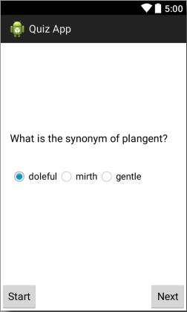

## Data (10 Points)

The data for the quiz is represented declaratively as XML resources.

## Activities (30 Points)

Create the following Activities at minimum:

|  |  |
| --- | --- |
| Activity | Description |
| MainActivity (20) | Displays the questions |
| ScoreActivity (10) | Displays the score |

## Design (10 Points)

User interface design for the app